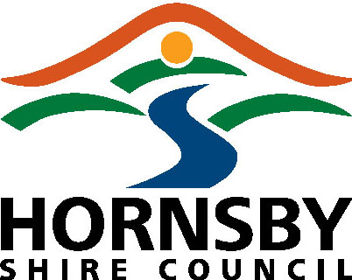 Owner’s Consent Form

Property Description | Lot No. DP No. Unit/Shop/Street No.
Property Description | Street Name: Suburb:

As the owner(s) of the land, I/we consent to the applications identified above being made to Council. I/we hereby permit any duly authorised officer of Hornsby Shire Council to enter the subject land or premises to carry out inspections and surveys or take measurements or photographs as required for the administration of the Act(s), Regulation or Planning instruments.
Note: For a Strata Title, the consent of The Owners Corporation is required.
In signing this application I declare that I am aware of and acknowledge Council’s Political donations and privacy policies
Name | Signature | Date
Company / School / Organisation:

Name and Position held:

